SRS-DLD

S/W Detailed Level Design

Project Name | Currency Exchange System — Release 3
Block Name | Compile Commander
Author | Magnus Jaaska | Approver
Team | Compile Commander

This document represents Detailed Level Design (DLD). It describes the detailed system design and implementation plan in alignment with Agile principles. The DLD is updated incrementally with each release to reflect system evolution.

Contents

1. Overview Error! Bookmark not defined.
2. System Overview / Architectural Context Error! Bookmark not defined.
3. UML Class Diagram (Technical Design) Error! Bookmark not defined.
4. Class Specifications Error! Bookmark not defined.
5. Interfaces and Abstractions Error! Bookmark not defined.
6. Function Responsibilities Error! Bookmark not defined.
7. Operation Flow Error! Bookmark not defined.
8. Enumerations & Constants Error! Bookmark not defined.
9. Validation Rules & Future Work Error! Bookmark not defined.
10. Traceability Matrix Error! Bookmark not defined.
11. Code Structure and File Mapping Error! Bookmark not defined.
12. Revision History Error! Bookmark not defined.
13. Validation Rules & Preconditions/Postconditions 13
14. Behavioral Models 14
15. Error & Exception Handling Policy 15
16. Revision History 16

- Revision History
Version | Date | Revised contents | Author | Approver
1.0 | 28.10.2025 | Initial Release 2 DLD; three-layer refactor; interfaces; method responsibilities; traceability. | Magnus Jaaska
- Terms and Abbreviations
Term | Description
UI | User Interface (ConsoleUI)
DLD | Detailed Level Design document
SRS | Software Requirements Specification
DIP | Dependency Inversion Principle
SRP | Single Responsibility Principle
- References
- SW Requirements Specification (docs/release-1/SRS.pdf)
- Lecture 5–7 (Design for Quality, Modularity, Abstraction, Polymorphism)
- Example DLD Currency Exchange (reference structure)

Overview
The Currency Exchange System automates currency conversion, verifies reserves before payout, records transactions in memory, and provides a daily summary. This DLD defines the Release 2 design: modular three-layer architecture (UI → Logic → Data), class responsibilities, interfaces, function contracts, constants, operation flow, and SRS traceability. Validation, exception handling, and file-based persistence are planned for Release 3.

System Overview / Architectural Context
- UI: ConsoleUI — console interaction & formatting only.
- Logic: ExchangeManager — coordinates conversion, reserve checks, and reporting.
- Data: ICurrencyRepository / CurrencyRepository — in-memory balances & exchange rates.
Principles: Separation of Concerns, SRP, DIP, encapsulation via header/source split.

UML Class Diagram (Technical Design)

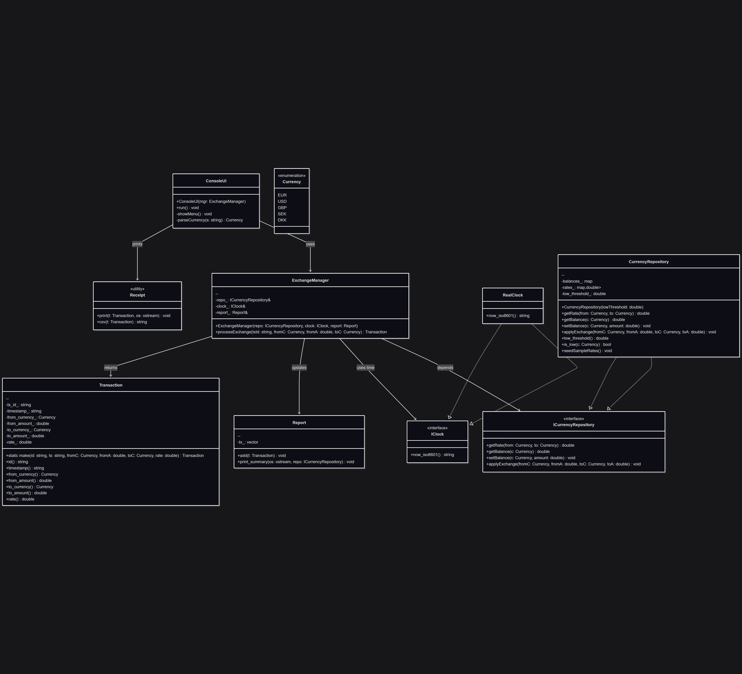

Class Specifications
Class | Type | Description | Attributes | Methods
ConsoleUI | UI | Console I/O and formatting; no business logic. |  | run(), parseCurrency(s), showMenu()
ExchangeManager | Logic | Coordinates exchange; checks reserve; updates report. | repo_: ICurrencyRepository&, clock_: IClock&, report_: Report& | processExchange(txId, fromC, fromA, toC): Transaction
ICurrencyRepository | Interface | Abstracts data access for rates/balances. |  | getRate(from,to), getBalance(c), setBalance(c,amt), applyExchange(fromC,fromA,toC,toA)
CurrencyRepository | Data | In-memory balances & rates; implements interface. | balances_, rates_, low_threshold_ | getRate(), getBalance(), setBalance(), applyExchange(), is_low(c), seedSampleRates()
Transaction | Domain | Immutable exchange record w/ computed to-amount. | tx_id_, timestamp_, from_currency_, from_amount_, to_currency_, to_amount_, rate_ | static make(id,ts,fromC,fromA,toC,rate): Transaction
Report | Domain | Aggregates transactions; prints daily summary. | tx_: vector<Transaction> | add(t), print_summary(os, repo)
Receipt | Utility | Formats receipt and CSV line. |  | print(t, os), csv(t): string
IClock | Interface | Time abstraction. |  | now_iso8601(): string
RealClock | Service | System clock implementation. |  | now_iso8601(): string

5. Interfaces and Abstractions

Interface | Purpose | Key Methods | Planned For (Release)
ICurrencyRepository | Decouple logic from storage; enable File/DB later | getRate(), getBalance(), setBalance(), applyExchange() | R2 (implemented)
IClock | Decouple time for tests | now_iso8601() | R2 (implemented)

6. Function Responsibilities

Class | Method | Purpose | Input | Output | Notes
ExchangeManager | processExchange() | Computes payout, checks reserve, applies exchange, records transaction | txId, fromC, fromA, toC | Transaction | Throws on insufficient reserve/bad rate
CurrencyRepository | applyExchange() | Update balances for from/to | fromC, fromA, toC, toA |  | Encapsulated state change
Report | add() | Append to daily collection | Transaction |  | Called after success
Report | print_summary() | Emit daily totals/closing balances | ostream, ICurrencyRepository |  | Presentation kept minimal
Receipt | print() | Human-readable receipt | Transaction, ostream |  | UI use
Receipt | csv() | CSV transaction line | Transaction | string | For logging later
RealClock | now_iso8601() | Timestamp |  | string | Local ISO-8601
ConsoleUI | run() | Interactive loop; parse/execute | stdin | stdout | Uses manager; handles errors

7. Operation Flow
- ConsoleUI reads input (“EUR 100 USD”).
- Parses → ExchangeManager::processExchange().
- Manager gets rate from ICurrencyRepository, computes payout.
- Validates reserves → applies exchange in repo.
- Creates Transaction, adds to Report.
- UI prints Receipt; session end → Report::print_summary().

8. Enumerations & Constants

Name | Value / Type | Description
enum class Currency | {EUR, USD, GBP, SEK, DKK} | Supported currencies
LOW_THRESHOLD | double = 100.0 | Alert threshold for low balances
INITIAL_BALANCES | per-currency doubles | Startup config for interactive run

9. Validation Rules & Future Work
Rule / Planned Feature | Description | Target
Input validation & errors | amount > 0, valid currency codes; clear error messages | R3
Strict reserve enforcement | Block payout > reserve; error codes | R3
Exception policy | try/catch at UI; noexcept in Data | R3
File I/O persistence | Save/load rates, tx, reports | R3
Unit tests | Mock IClock & repo; per-layer tests | R3

10. Traceability Matrix
Requirement (SRS) | Class / Method (DLD) | Notes
RQ-01 Convert currency | ExchangeManager::processExchange() | Core conversion via repo rate
RQ-02 Show receipt | Receipt::print(), ConsoleUI::run() | UI formatting only
RQ-03 Maintain reserves | CurrencyRepository::applyExchange() | Encapsulated data update
RQ-04 Daily report | Report::add(), Report::print_summary() | End-of-day summary
RQ-05 Time stamps | RealClock::now_iso8601() | Abstracted time

11. Code Structure and File Mapping
Class / Module | Files
ConsoleUI | include/console_ui.h, src/console_ui.cpp
ExchangeManager | include/exchange_manager.h, src/exchange_manager.cpp
ICurrencyRepository | include/currency_repository.h (interface)
CurrencyRepository | include/currency_repository.h, src/currency_repository.cpp
Transaction | include/transaction.h, src/transaction.cpp
Report | include/report.h, src/report.cpp
Receipt | include/receipt.h, src/receipt.cpp
IClock / RealClock | include/iclock.h, src/iclock.cpp
Entry point | src/main.cpp
Build | Makefile

12. Revision History

Date | Version | Change Summary | Author
28.10.2025 | 1.0 | Initial DLD created from Release 2 refactor | Magnus Jaaska

Release 3

13. Validation Rules & Preconditions/Postconditions
< Describe how your system checks input data and enforces correctness before and after operations. Each method should list clear preconditions (what must be true before it runs) and postconditions (what must be true after it completes). Indicate the layer where validation happens - UI, Logic, or Repository. Use the same class and method names as in Release 2.>
Class | Method | Preconditions | Postconditions | Validation Level (UI/Logic/Repository) | Explanation
ConsoleUI | run() | Input fields present | Input values captured | UI | Validates all required fields are entered
ExchangeManager | processExchange() | fromA >= 0, currency codes valid | Transaction created, balances updated | Logic | Validates business rules before Repository call
CurrencyRepository | getRate | Rate pair exists | Returns rate or throws exception | Repository | Confirms data availability
CurrencyRepository | applyExchange | All validations passed | Balances updated successfully | Repository | Applies validated exchange

14. Behavioral Models
< Attach two UML diagrams that describe one key operation in your system, for example, processing an order, confirming a booking, or updating a record. Both diagrams must describe the same operation to show consistency.
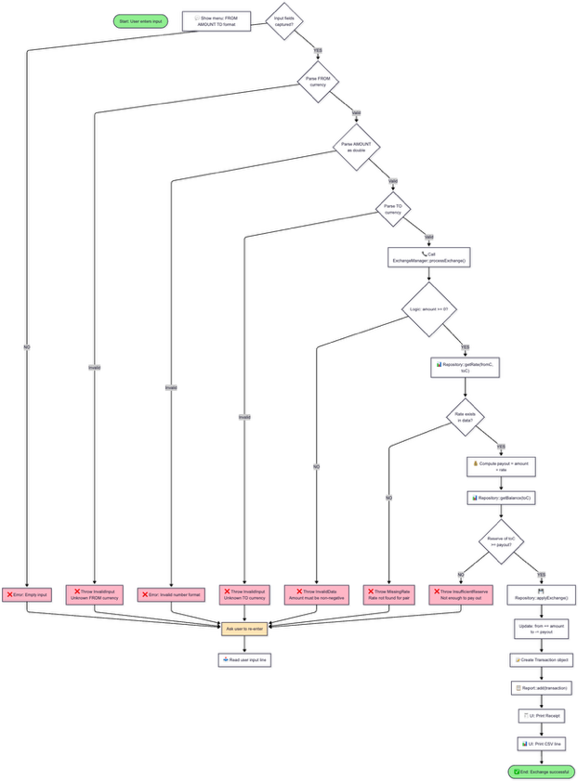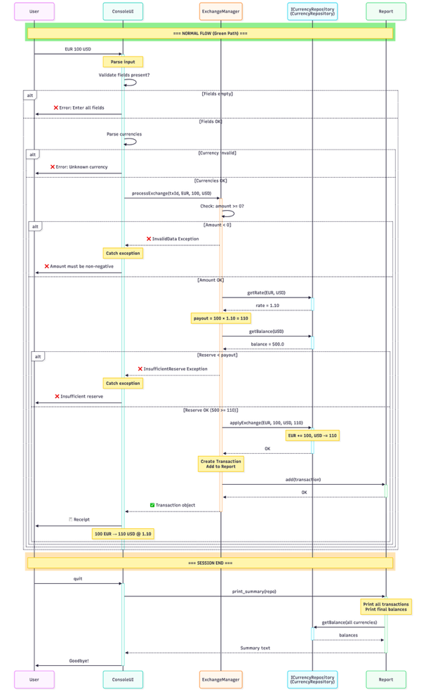

15. Error & Exception Handling Policy
< List all exceptions that may occur in your system. Describe where each one is thrown, where it is caught, what message it shows, and what the program does afterwards.
For this release, use only the three architectural layers: UI, Logic, Repository. >
Exception Type | Thrown By (Layer / Class) | Caught At (Layer) | Message / what() | Default Action (message / stop / retry)
InvalidInput | UI — ConsoleUI input parsing or parseCurrency() | UI | "Please enter all required fields." | Show message → ask user to re-enter
InvalidInput | UI — ConsoleUI parseCurrency() | UI | "Unknown currency: {code}. Supported: EUR, USD, GBP, SEK, DKK" | Show message → ask user to re-enter
InvalidData | Logic — ExchangeManager::processExchange() guard clause | UI | "Amount must be non-negative." | Show message → stop operation
InsufficientReserve | Logic — ExchangeManager::processExchange() reserve check | UI | "Insufficient reserve of {currency} to pay out {amount}." | Show message → stop operation
MissingRate | Repository — CurrencyRepository::getRate() | UI | "Exchange rate not found for pair {from}/{to}." | Show message → stop operation

16. Revision History
<Track document changes across releases. >
Date | Version | Change Summary | Author
28.10.2025 | 1.0 | Initial Release 2 DLD; three-layer refactor; interfaces; method responsibilities; traceability. | Magnus Jaaska
23.11.2025 | 2.0 | Release 3 update: Added Section 13 (Validation Rules), Section 14 (Activity & Sequence Diagrams), Section 15 (Exception Policy). Documented processExchange() as core operation with complete validation, behavior, and error handling flow. | Magnus Jaaska

